1. Utility Application

Weather App

Description: The weather app provides currents weather information in Townsville City, Queensland, Australia.

Features of Weather App”

* Current weather info: Detailed real-time weather report, including real-time weather status, temperature, humidity, clouds and wind speed.
* Temperature convert: Changing between Fahrenheit degree and Celsius degree

Screenshot:

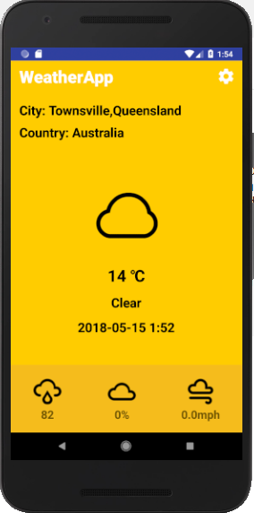 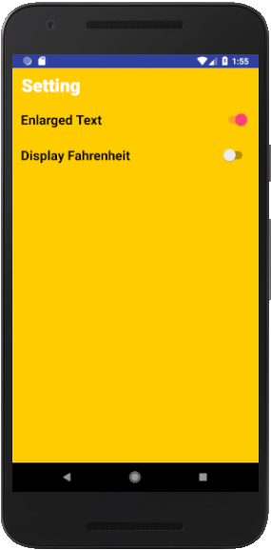

1. Educational Application

Sum Up Game

Description:

* The education game to help kids from 7-12 years old to improve mathematics skills by playing game
* By playing, kids can break their own high scores in this game
* Kids can share their high score with their friends
* Game combine music, image and many features that suitable with kids

Screenshot:

 